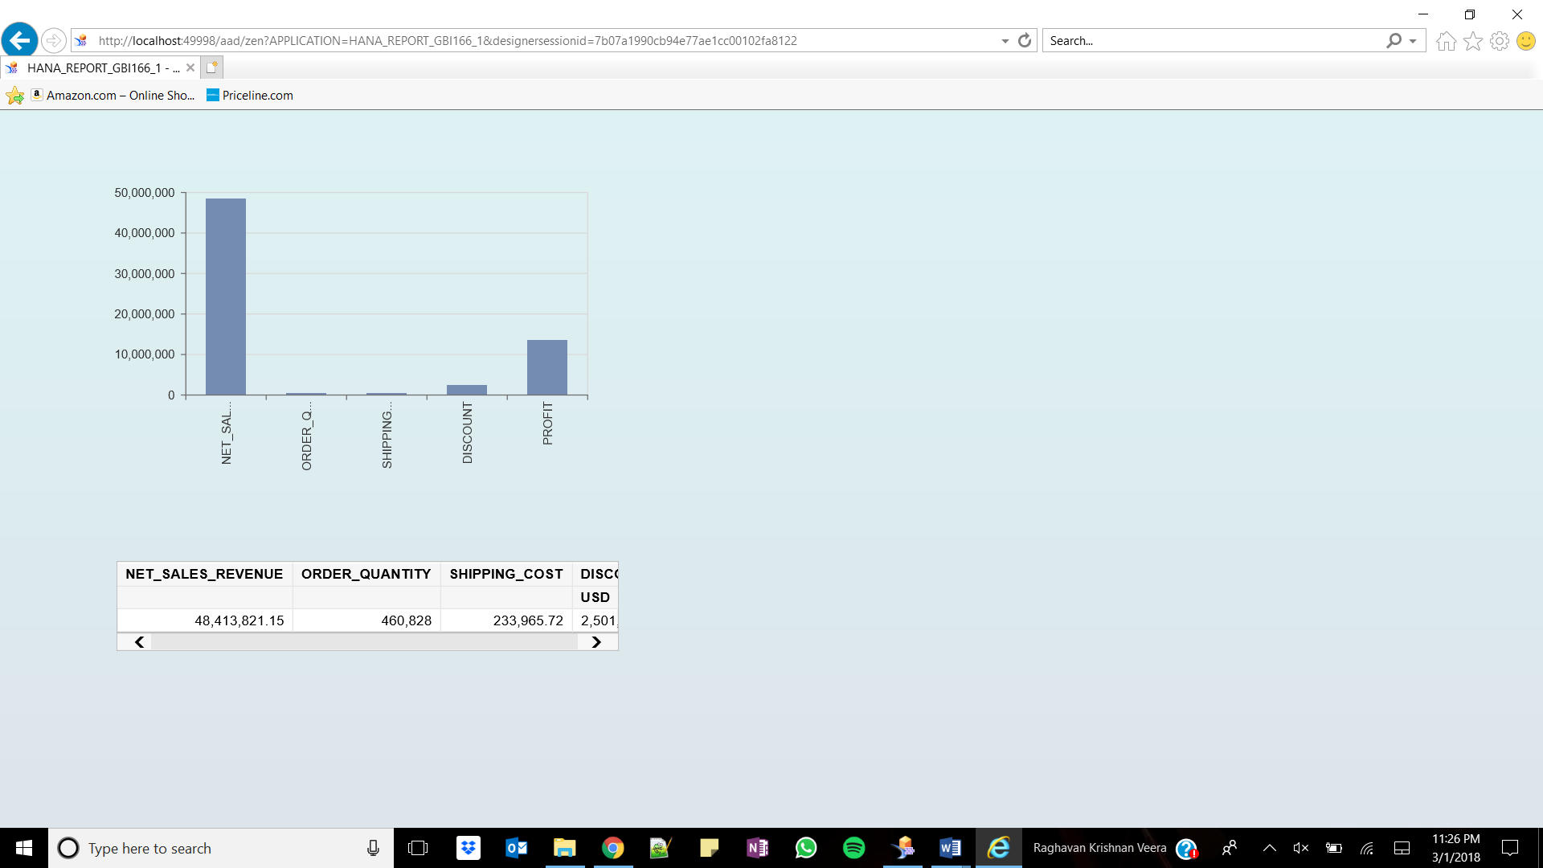

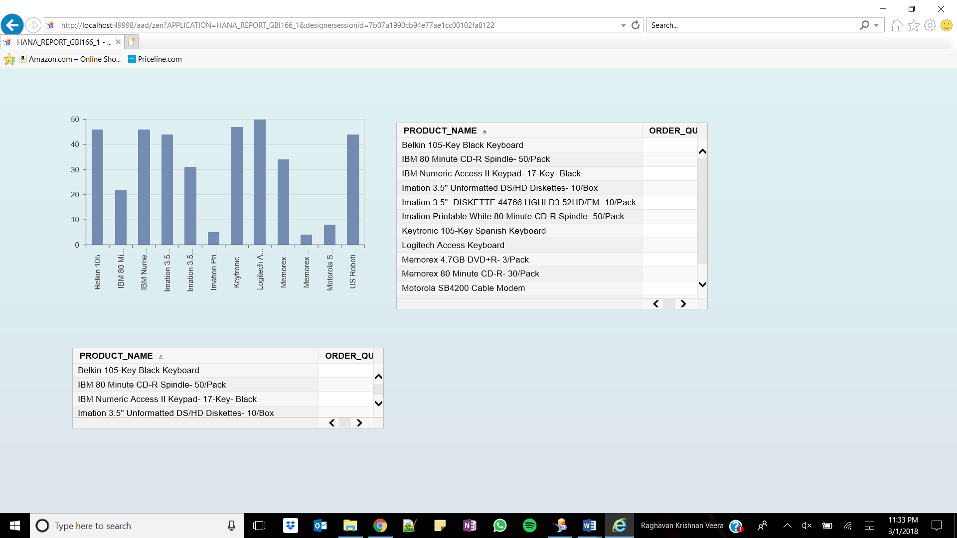

Logitech Access Keyboard was ordered the most

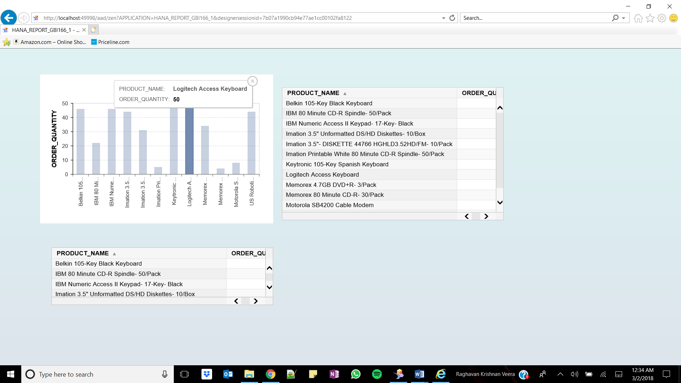

The ordered quantity of Memorex 4.7GB DVD+R- 3/Pack is 34

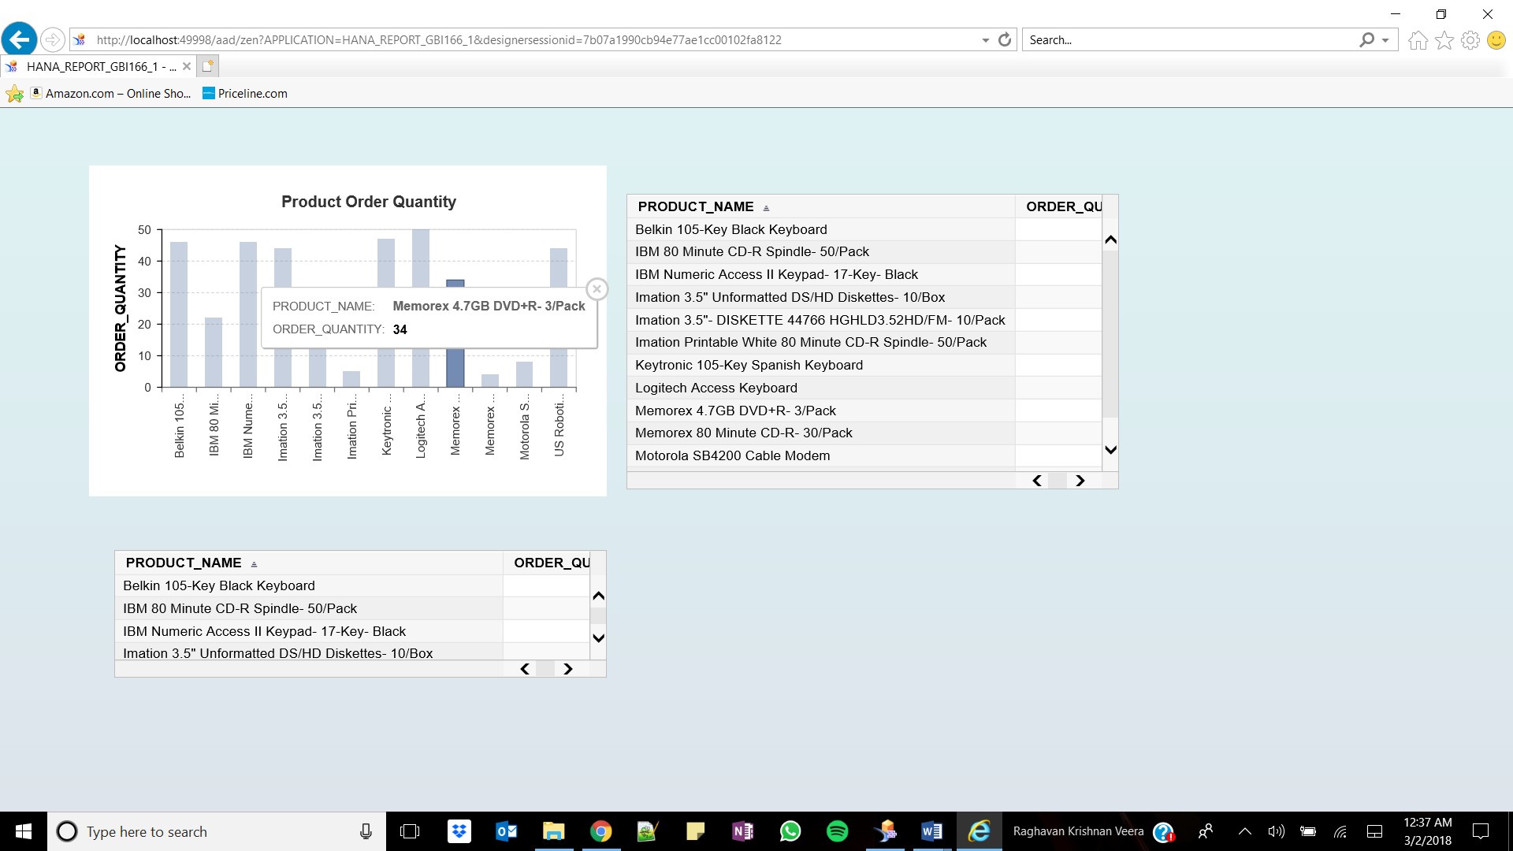

IBM Numeric Access Keyboard II Keypad was ordered the most 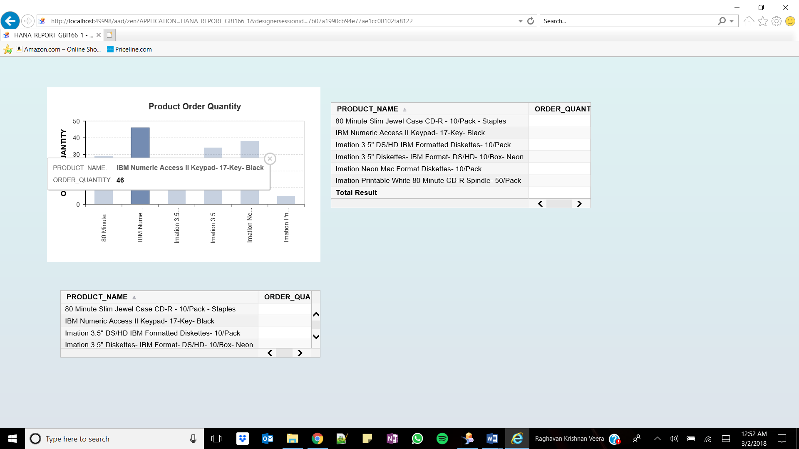

Net Sales Revenue of Sharp AL-1530CS Digital Copier is 104298.38 and discount is 5936.14 USD

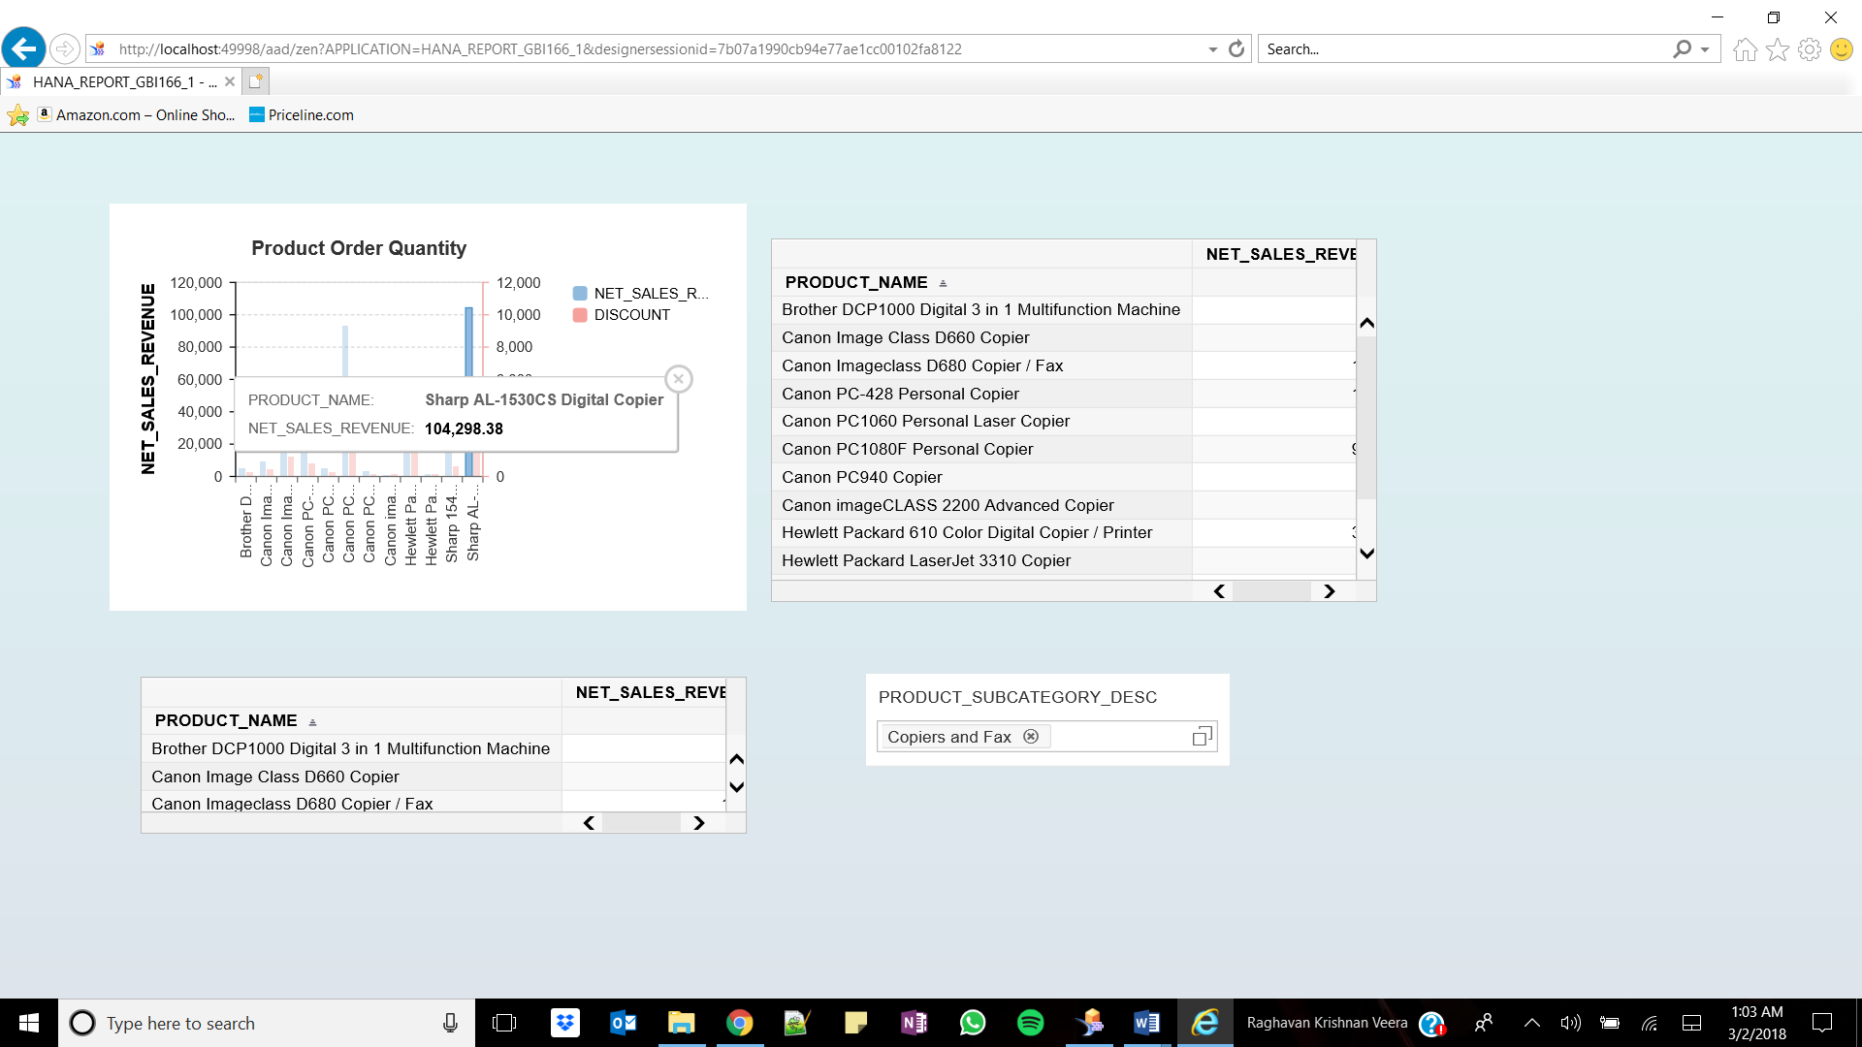

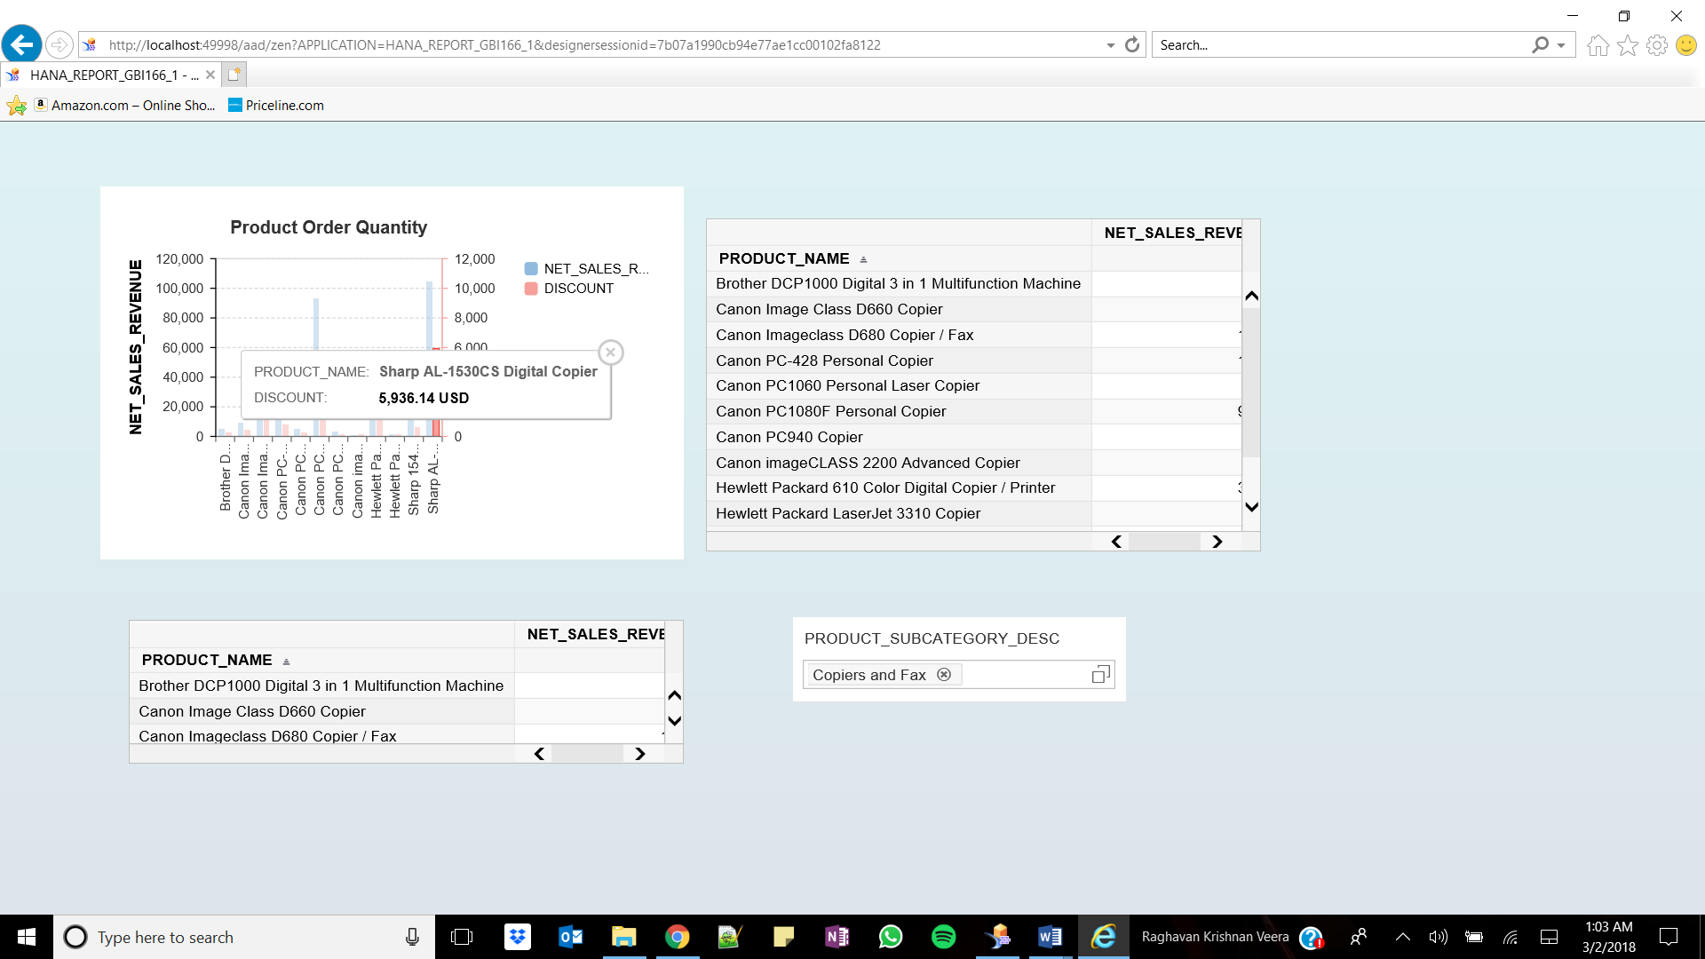

The discount of HP 610 Color Digital Copier/ Printer is 1742.64

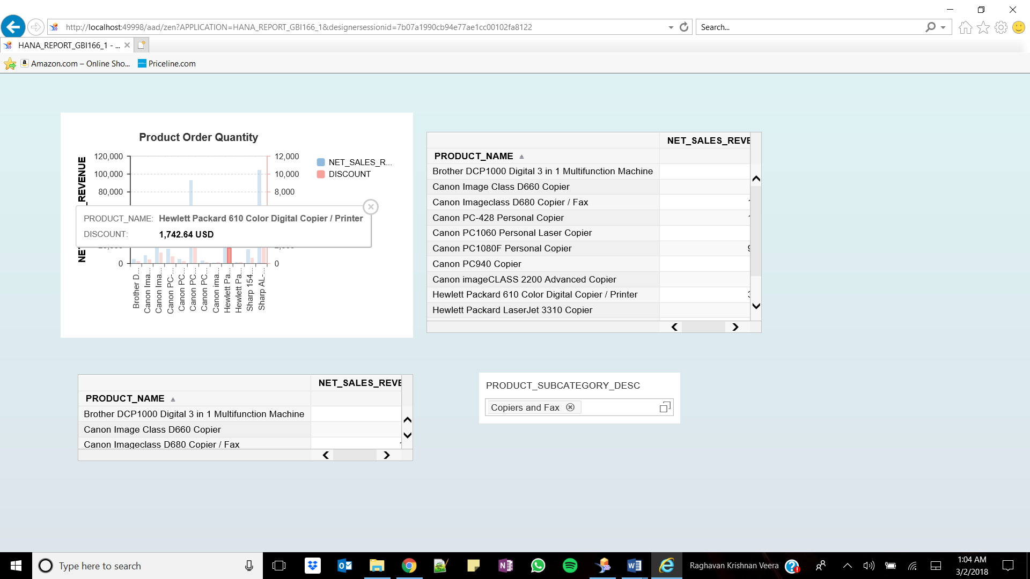

Las Vegas has the highest revenue in 2024

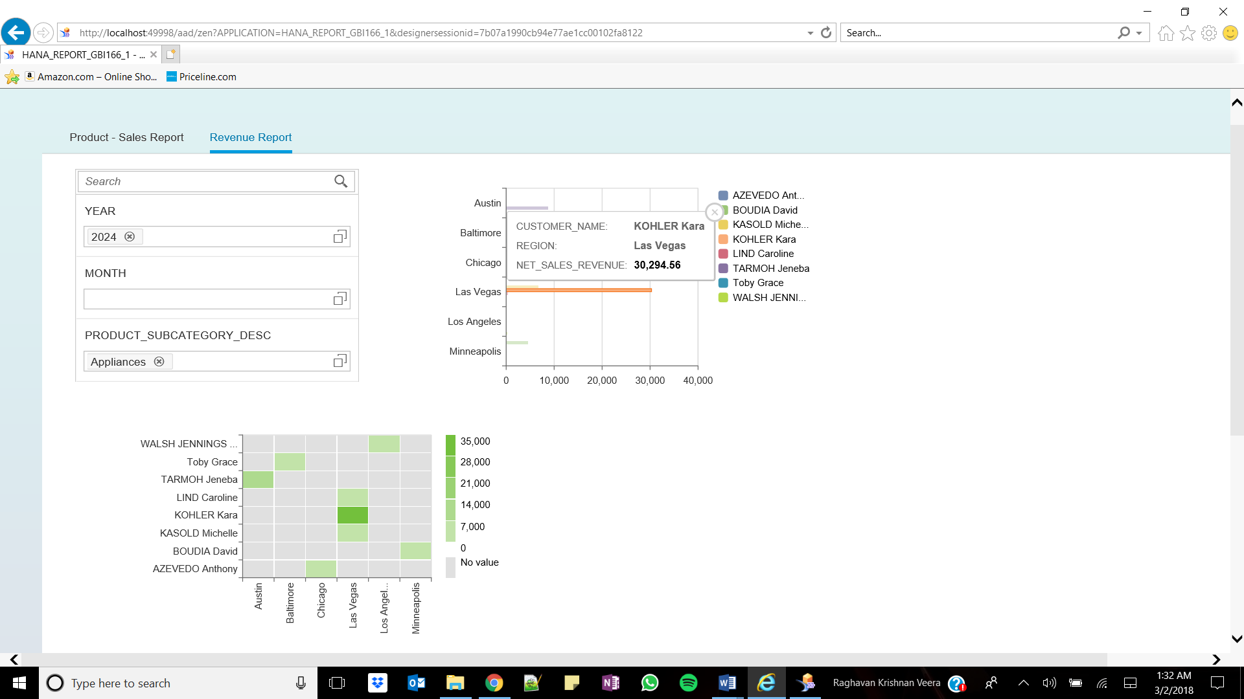

1075.93 is the revenue of Toby Grace

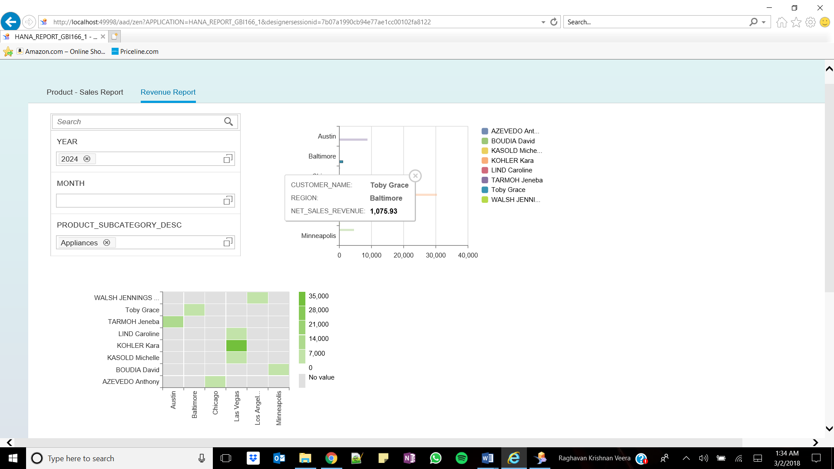

ANDERSON Haley, Kansas City generated the least revenue

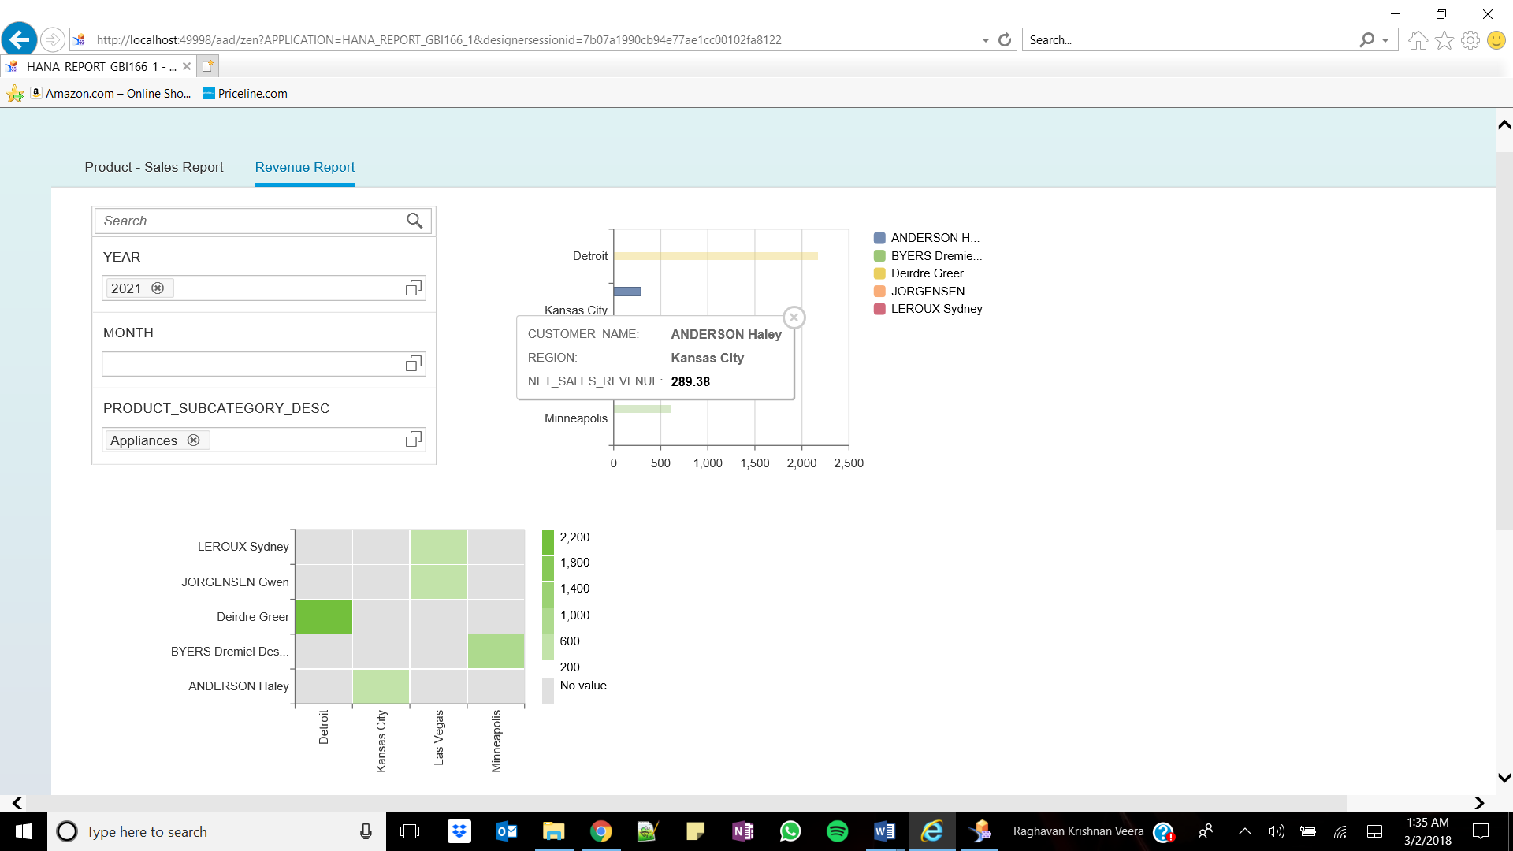

HARPER Dawn 120.32 & GIBB Jacob 119.00

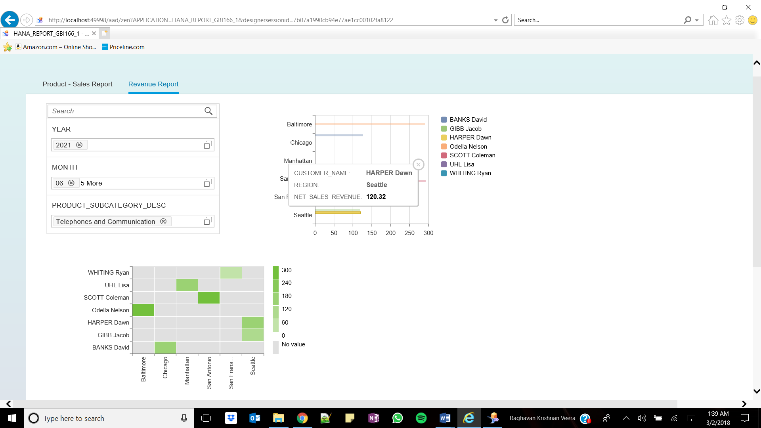

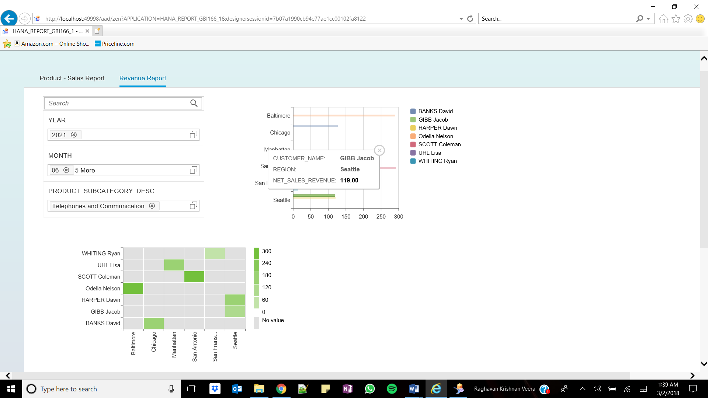

UHL Lisa 126.78 & Banks David 127.18

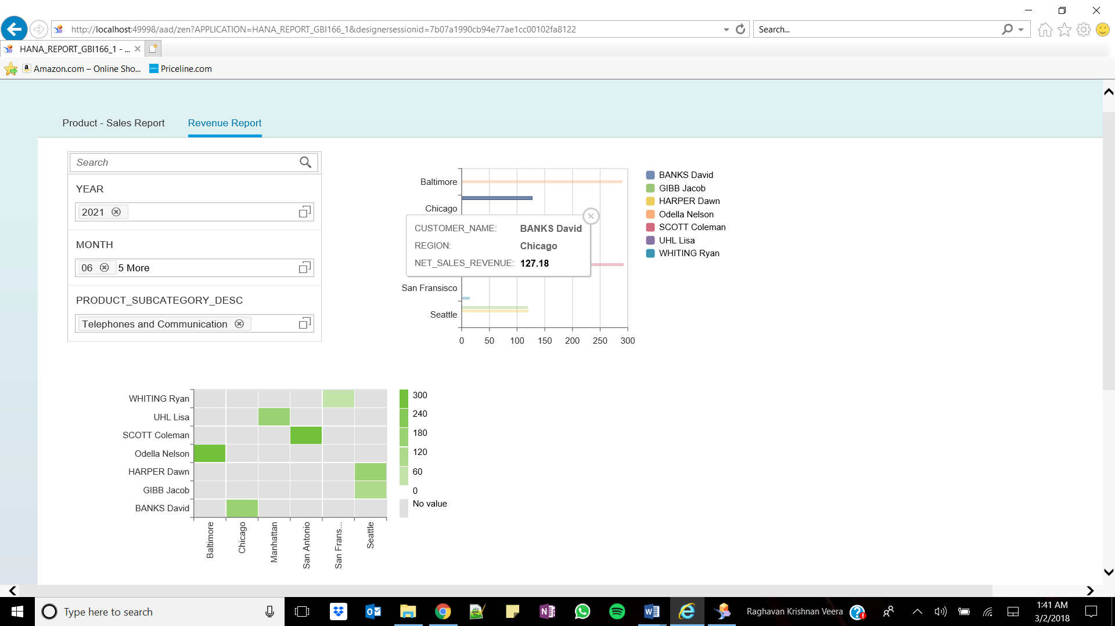

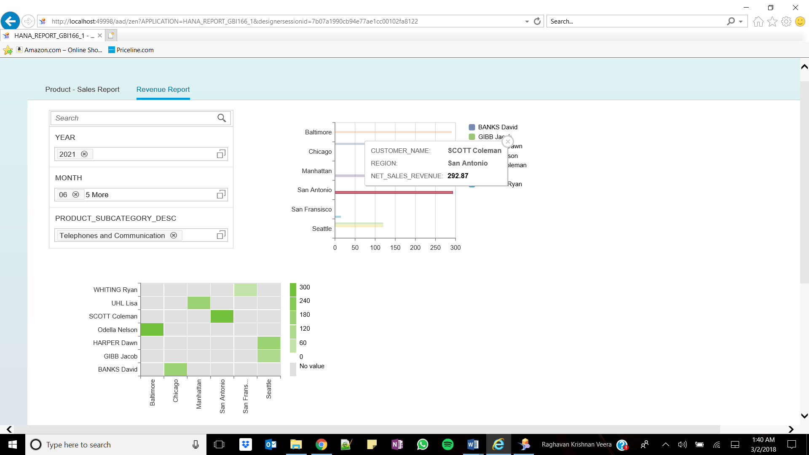

SCOTT Coleman 292.87 & Odella Nelson 290.24

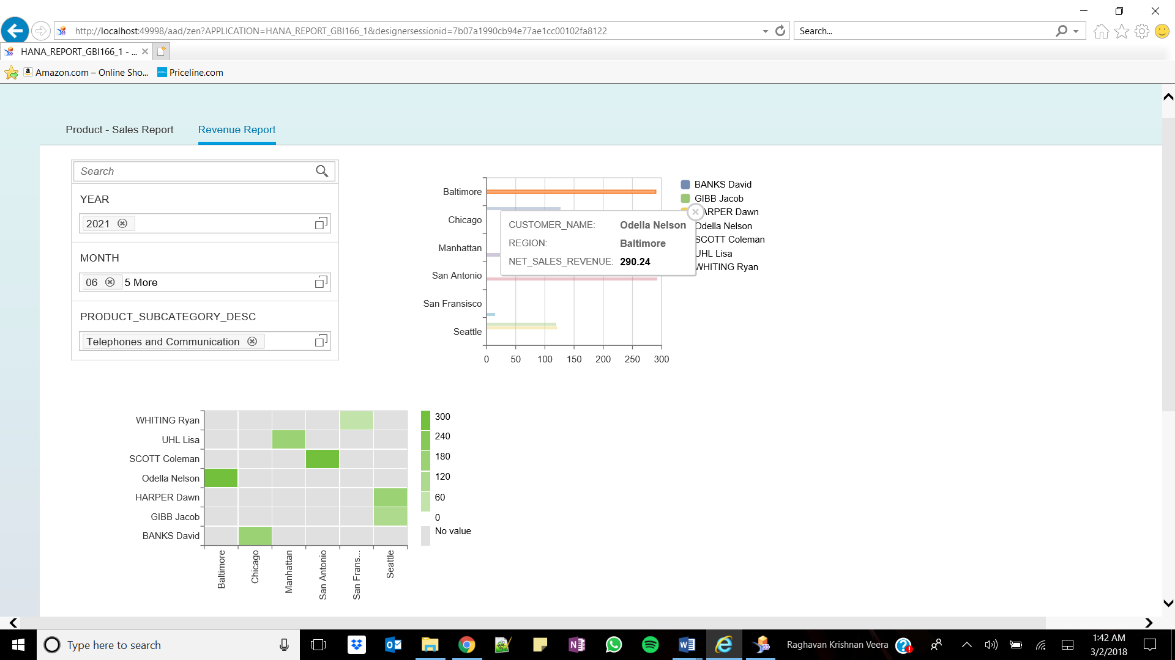

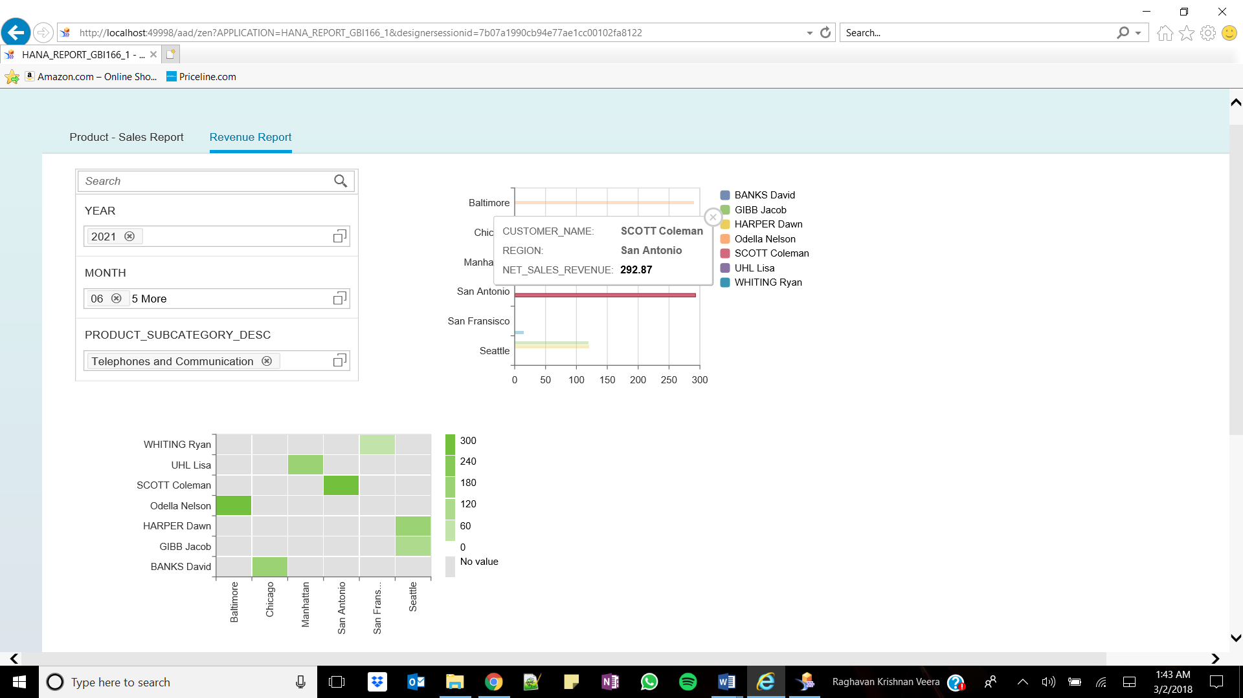

Top 3:

HOOKER Destinee 1105.92

SYMMONDS Nick 1047.13

CESAN Michelle 1021.16

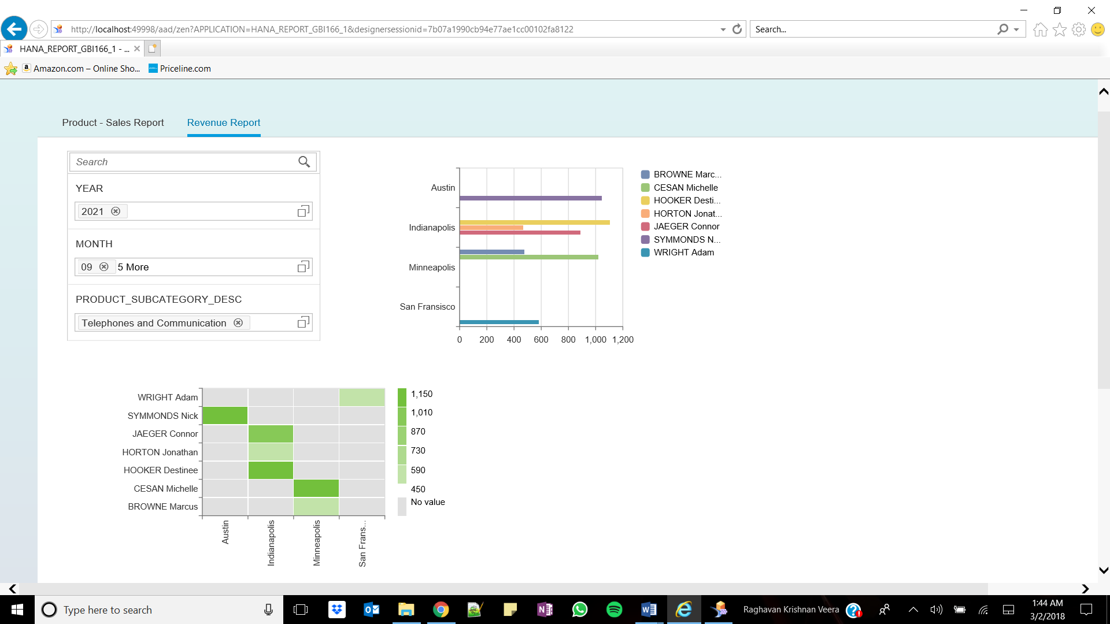

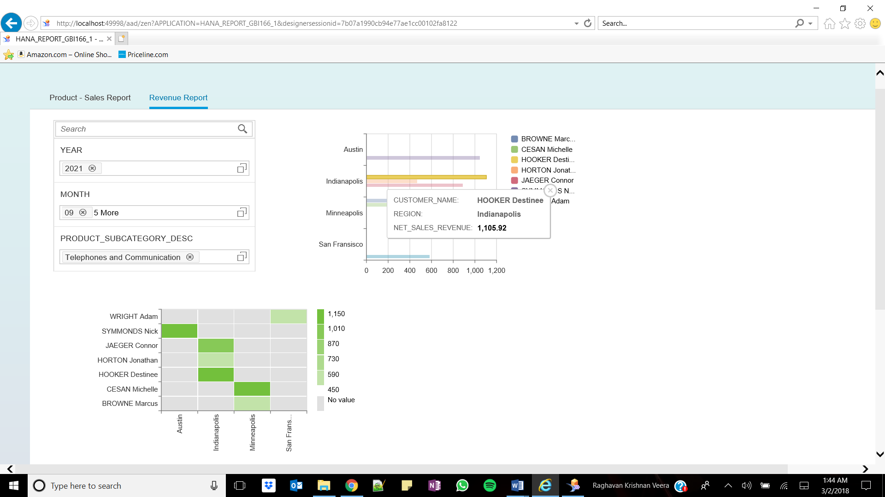

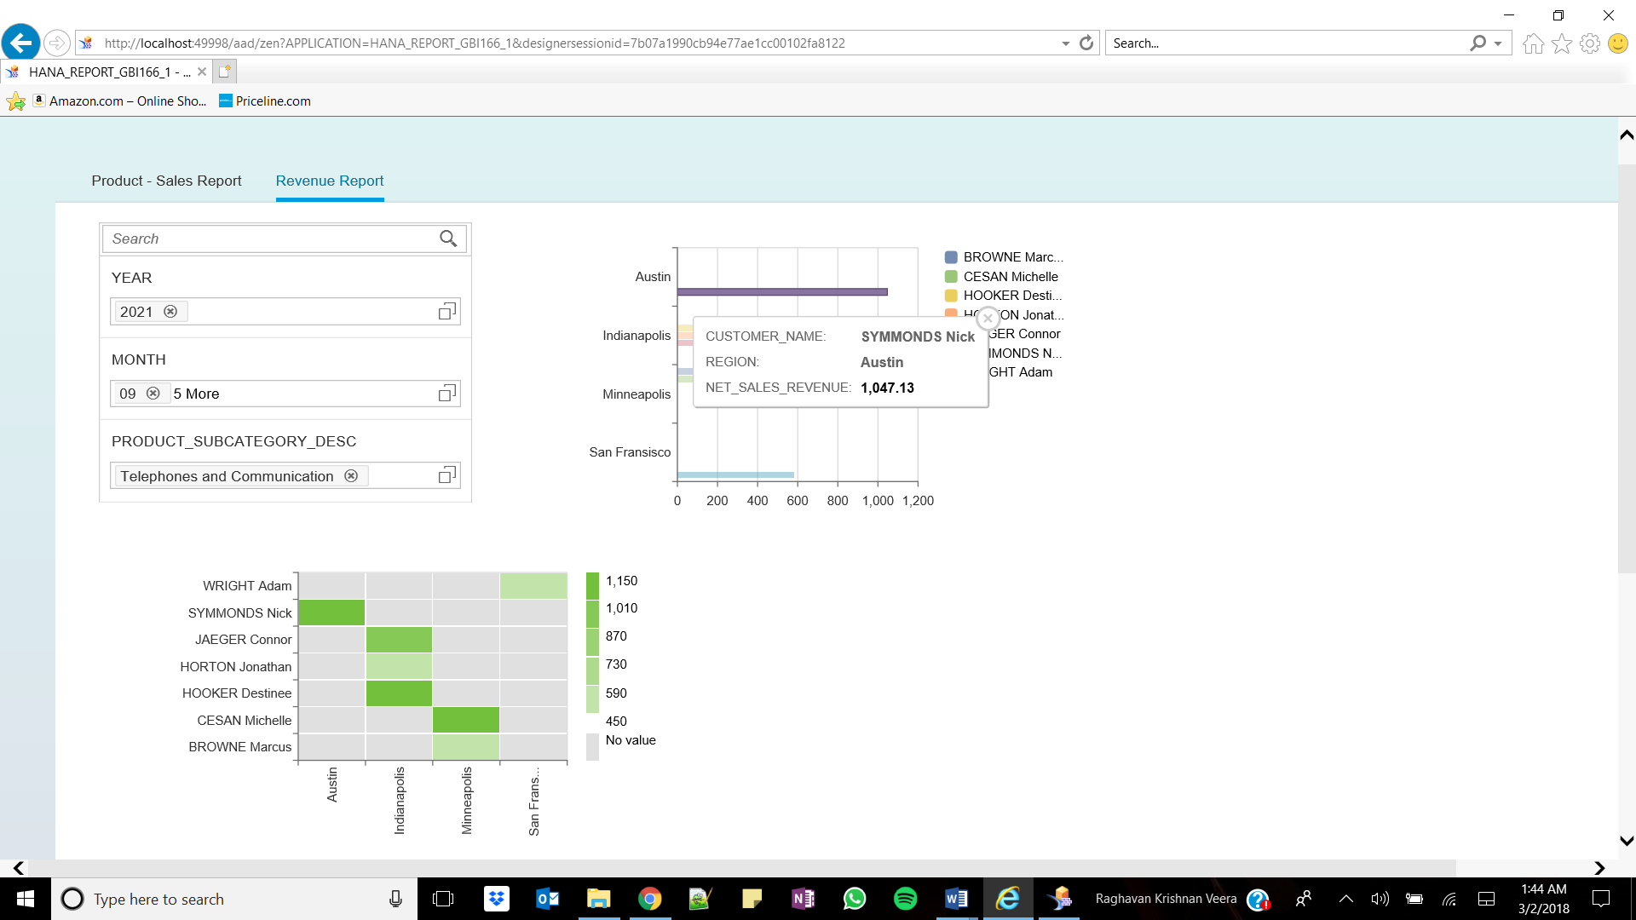

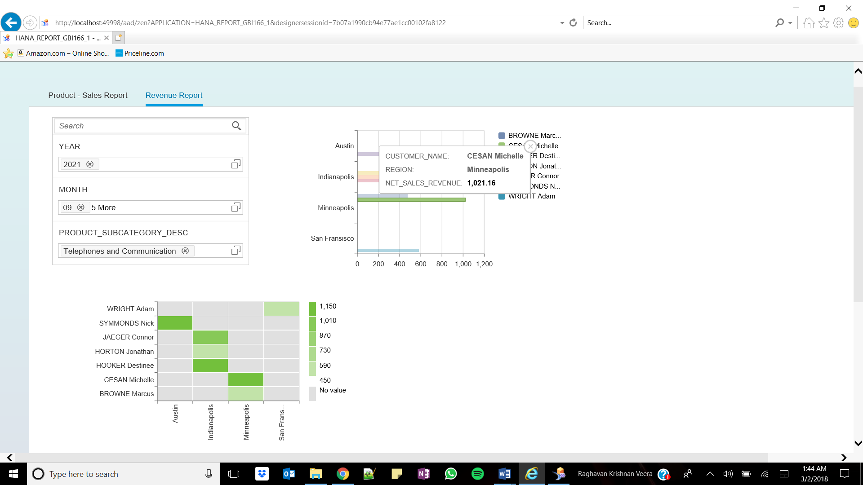

China, United States, United Kingdom

